Sequence and Data
Name:
Student ID:
Date:

Learning Journey and Evidence
To learn about sequence and data I did the following.

<describe action>
<provide a screenshot of what you created related to this>
<describe what you learnt from this, what challenges were faced, or surprises>

<describe action>
<provide a screenshot of what you created related to this>
<describe what you learnt from this, what challenges were faced, or surprises>

<describe action – duplicate table as needed>
<provide a screenshot of what you created related to this>
<describe what you learnt from this, what challenges were faced, or surprises>

Brief Summary of Concepts
Concept | Key Idea / Concept
Program
Variable
Method
Method Call
Assignment Statement
Expression

Consider the following terms and diagram. Then, fill in the table below.
1 | This is code for a … .
2 | Instructions in the code follow a … , starting from the first line.
3 | This text is an … , which is passed to the call to WriteLine.
4 | This line of code contains a … to the … named … .
5 | This line of code contains an … . It calls the … named … and stores the result in the … named … .
6 | The code creates a … named … . It stores data with a … of “string”.
7 | This is the … . It determines the kind of data stored in the … named … .
8 | This is a … named … . It stores an … value.
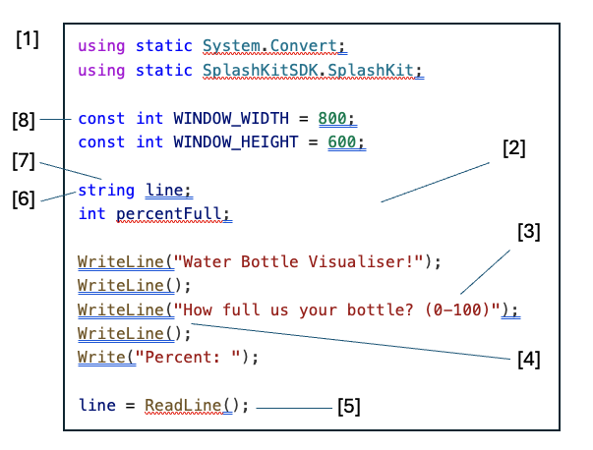
- Expression | - Method | - Variable | - Constant
- Sequence | - Type | - Method Call | - Argument
- Program | - Assignment Statement

Reflection

What is the most important thing you learnt from this and why?
Answer this question here. A few sentences to a paragraph should be sufficient.

What strategies did you use to help learn this material? How well did they work?
Answer this question here. A few sentences to a paragraph should be sufficient.

Based on what you have seen so far, what do you think your biggest challenge in this unit will be? Why? What strategies are you considering employing to overcome this?
Answer this question here. A few sentences to a paragraph should be sufficient.

